E-Commerce Database Project Documentation

Logical transformation
Task A (Price Categories): Select Title and a new column Stock_status; if Stock< 10 then 'Low stock', else 'In Stock'.
SELECT product_name,
CASE
WHEN stock = 0 THEN 'Out of Stock'
WHEN stock < 10 THEN 'Low Stock'
ELSE 'In Stock'
END AS stock_status
FROM products;
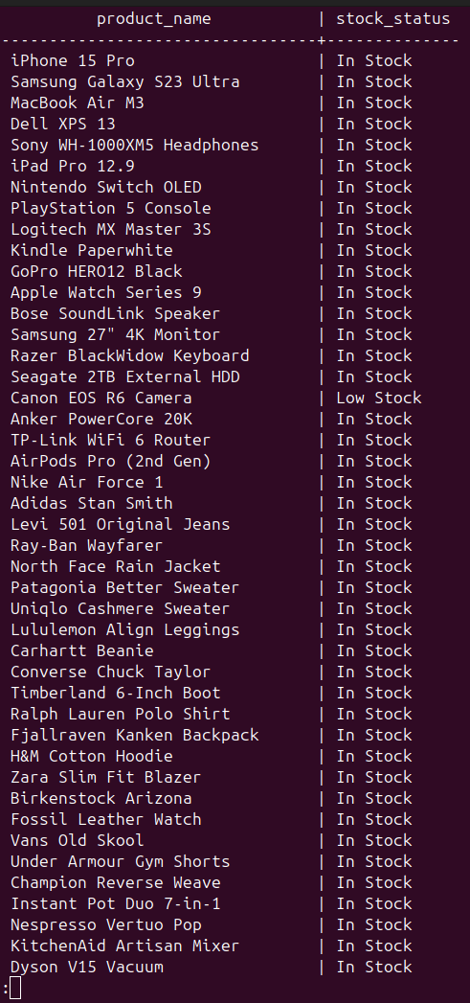

Task B:

This query creates a new column named payment_category using the CASE expression.
If the amount is less than 100, the payment is labeled as 'Small Payment'.
If the amount is between 100 and 1000, the payment is labeled as 'Medium Payment'.
For all other amounts, the payment is labeled as 'Large Payment'.

SELECT order_id, amount,
CASE
WHEN amount < 100 THEN 'Small Payment'
WHEN amount BETWEEN 100 AND 1000 THEN 'Medium Payment'
ELSE 'Large Payment'
END AS pPayment Category Labelsayment_category
FROM payments;

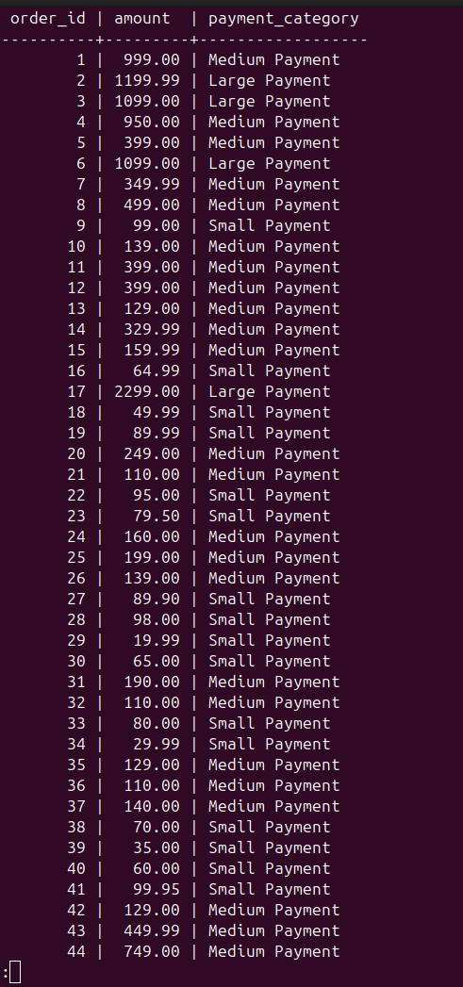

Task C:
This query creates a new column named AvailabilityStatus using the CASE expression.
If the product price is less than 2000, it is labeled as 'Vintage'.
Otherwise, it is labeled as 'Modern'.

SELECT product_name,
CASE
WHEN price < 2000 THEN 'Vintage'
ELSE 'Modern'
END AS AvailabilityStatus
FROM products;

